

**School of Public Administration  
Bachelor of Science in Computing**

**COMP407 Selected Topics II – IT Solutions for Business  
Final Report**2014/15 1st semester

|  |  |
| --- | --- |
| SugarCRM Improvement System | |
|  |  |
| Team number: | 3 |
| Team members: | Athena HOI Ka Wai (P1104463)  Sandy CHEN Wan Ping (P1107936)Key LIANG Yi Juan (P1107923) |
|  |  |
| Supervisor: | Dr. Benjiman Ng |
| Assessor: | Dr. Rita Tse |
|  |  |
| Submission Date: | Nov 17, 2014 |

**Table of Contents**

[1 Introduction 4](#_Toc403002996)

[1.1 Overview 4](#_Toc403002997)

[1.2 Objectives 4](#_Toc403002998)

[2 Background 5](#_Toc403002999)

[3 Methodology 8](#_Toc403003000)

[3.1 Requirement Elicitation 8](#_Toc403003001)

[3.1.1 Observation 8](#_Toc403003002)

[3.1.2 Scenario for SugarCRM 9](#_Toc403003003)

[3.1.3 Finding Problem 10](#_Toc403003004)

[3.2 Requirement Specification 12](#_Toc403003005)

[3.2.1 Functional requirements 12](#_Toc403003006)

[3.2.2 Non-functional requirements 13](#_Toc403003007)

[3.2.3 Domain requirements 14](#_Toc403003008)

[4 System Implementation 15](#_Toc403003009)

[4.1 Platforms 15](#_Toc403003010)

[4.2 Architecture 15](#_Toc403003011)

[4.2 Data Modelling 17](#_Toc403003012)

[4.2.1 Identifying entity type 17](#_Toc403003013)

[4.3 Enhancement to existing system 23](#_Toc403003014)

[4.4 Key problems and their solutions 23](#_Toc403003015)

[5 Results and discussion 24](#_Toc403003016)

[5.1 Project Outcome 24](#_Toc403003017)

[5.2 System evaluation 25](#_Toc403003018)

[5.2.1 Test Case 26](#_Toc403003019)

[Appendix 27](#_Toc403003020)

[Project plan 27](#_Toc403003021)

[Refernces 28](#_Toc403003022)

[Peer Assessment Form 29](#_Toc403003023)

# Introduction

## Overview

As the LT Game Company continues to develop, the quantity of business transactions and corresponding interactions with customers become larger. Consequently, a customer relationship management (CRM) system is of the greatest necessity and importance for the company. To meet their needs, SugarCRM is tried to be used in the company. However, some problems still occurs. The general aim of this project is to provide an enhanced CRM system to LT Game Company to replace SugarCRM.

## Objectives

* Get the information of the company and identify the problems in their IT system.
* Identify the requirement of the IT system.
* Proposed an enhanced CRM system that satisfies the requirements.
* Make the utilization of the system in the staffs reach 90%.

# Background

LT Game is one of the major gaming and casino providers in Macau and in the Asia Pacific region. The products mainly include the Live Multiple Games System (Which has live dealers, supports multiple table and has a terminal-based multi-game selection system) and the Paradise Jackpot System (Baccarat Side-Bet Progressive Jackpot). Both have been patented in Macau, USA and PCT (Patent Cooperation Treaty) countries. LT Game is striving to be at the forefront of the global gaming industry. Live Multiple Game (LMG) System provides first-rate live table gaming which is unparalleled in the electronic gaming world. The Live Multiple Games machines include Live Baccarat, Live Roulette, Live Sicbo, Live Blackjack, Live SanGong and Live Keno. The Paradise Jackpot is a patent granted Baccarat-based progressive jackpot. By linking up the side bet on the felt tables, players will be able to participate in the progressive jackpot in accordance to the DICJ’s (Macau Gaming Board) approved betting payout. Paradise Jackpot System is designed to be a cross-casino and cross-table system, it allows the jackpot pool size to increase in a rapid and enthralling rate.

The following is organizational structure of LT Game

CEO

Sales Admin

COO

IT Manager

Senior Manager

Project Manager

DB/System Engineer

Network Engineer

Potential Senior Technician

Assistant Technician Manager

Technician

Senior Technician

Potential Senior Technician

Technician

According to the organization structure of LT Game, before system changing in functions are admitted, the technician would discuss and deliver the changing plan to potential senior technician, if the senior technician thinks the plan is valuable, and then he/she would deliver the plan to the DB/System engineer. After that the DB/System engineer, project manager and COO will have a meeting to discuss the plan. If it goes well, the plan will be executed.

In LT Game there are many kinds of issues in marketing, sales, customer service and technical service. It’s hard to integrate the information without a customer relationship management (CRM) system. For example, there are lots of after-sale services in the LT Game, CRM system could track every service until it solved. A quality CRM system can help the company organize, automate and synchronize well the information, improve the efficiency, thus makes profit for company. It also enables the company to obtain business dealings with customers in a more systematic way in the market.

SugarCRM is a customer relationship management (CRM) system that is available in both open-source and commercial open-source applications. It enables businesses to create extraordinary customer relationships with the most innovative and affordable CRM solution in the market. It has a flexible management system and perfect IT equipment management function, which makes the process of managing customer relationships systematically. It is not only a management system, but the system also allows the user to know the solution for sales. So that customers can trust providers more. As a result, SugarCRM system can enhance the competitiveness of the enterprise and service quality.

The popular company IBM, has chosen SugarCRM for its lucrative CRM contract. In February 2012, Blytheco similarly chose to end its 30-year relationship with Sage in favor of SugarCRM.

In this project, the aforementioned background information of LT Game will play an important part in making decisions as to how to find the right IT solution for solving its business problems.

# Methodology

## Requirement Elicitation

In order to improve SugarCRM system, gathering information of user requirements is necessary, thus we arranged Athena to go to the company and spent 3 months to take part in the operation and gain experience of operating the system. The following issues are found via work experience on an internship in LT Game.

### Observation

According to the organization structure of LT Game, some special behavior about SugarCRM system are found in different position for 3 months observation.

1. COO

She agrees and supports to use the system. She thinks that the system can help the company management and provide better customer service. Unfortunately, there is not enough human resource to solve general operating problem. Otherwise, she believes that the system would run more smoothly and better.

1. Network Engineer

He thinks his solve problem is too short no need to report in the system. If he spends the time to type in data, the problem maybe have been figure out already.

1. DB/System Engineer

He keeps update the status of cases in the system which have been assigned to him before.

1. Project Manager

He has the most expectation for the system. He wants to improve the system and add different modules such as e-mail reminder, analyze report. He thinks that the system can help the company improve its business.

1. Senior Manager

He thinks that the system is an important tool for the company. If the system operates to mature stage, it will be an important system for the development of the company.

1. IT Manager

He keeps tracking those case in the system.

1. Assistant Technician Manager

In general situation, all the case will assigned to him by default first. He needs to assign other technician to follow the case. But he thinks that he doesn’t have enough time to response this work.

1. Senior Technician

He thinks that he doesn’t have enough time to entry all record.

1. Potential Senior Technician

He never use the system after few description. He doesn’t know about using significance of the system.

1. Technician

He never use the system after few description. He doesn’t know about using significance of the system.

### Scenario for SugarCRM

Each company has its own operation procedure. This part will show the real-life of how SugarCRM is used in LT Game routine work.

#### Initial assumption

There are three situations will create a case. Firstly, when floor manager finishes the routine inspection, he/she will write a excel document for problem machine. Secondly, floor manager also will make a phone call to the IT support. Reporting some machines have problem. Thirdly, some big cooperation plans also will be created by manager in LT Game in the system.

#### Normal

On the one hand, every afternoon when operator receives the routine inspection report, he/she will entry the problem machine case into the system and inform assistant technician manager. In addition, he/she checks the cases already in both the system and the routine inspection report. Operator will check the corresponding machine has been maintained or not on the basis of a maintenance form. If the case was completed, the status of case will be changed to close. On the other hands, the big case will be updated when it has new resolution.

#### What can go wrong

When operator receives a maintenance form, he/she will update the status of corresponding case in the system. Unfortunately, he/she can’t search the corresponding machine have been created before. So the case will lose tracking.

#### Other activity

Everyone who has been register before can edit the case. When someone change the case status or assigned, the system will create a log for those changes.

#### System state on completion

The case record is entered in the database and is added to the system log showing the create time with creator in the home page.

### Finding Problem

After using SugarCRM, some technical problems can be found in the system. If the technical problems were solved, it can be more efficiency.

#### Search engine

The search engine only works when search the first letter or word. If user wants to search the key word in a subject, it can’t be work. For example, the search engine would work if “specific lottery machine” is searched, but if the key word is “lottery machine”, then the search engine would not work.

Sometime users may want to find the machine for same special reason. When typing the key word such as hand pay, the system can’t find any result. Because of the subject name is always named by machine number first.

#### Interface

SugarCRM provides to different department to use. But each account can see the same function in the interface. For example, marketing department staff just want to know about analyzing of a tournament. But the system will show all the data to her/him within all cases (problem machines).

Different kind of user should use different functions in the system, so the interface of system they see should be different. However, in the origin system when different kind of users login, the system shows the same interface.

#### Import/export

The system can export only English word in case. If the tittle is Chinese word, it will show unreadable code. However, if input some data in the system. Operator just can use its template. But there is nobody follows the structure. So in order to improve the system, a better way of data input should be proposed.

Senior technician needs to submit his/her work report which involves maintenance problem machine etc. The work report have its own template. If it can directly import into system, senior technician will save the data entry time.

#### Create a client server

SugarCRM system just can be used in the sky office. When the machines in the casino have problem, the floor manager in the casino will call the IT department of LT Game and inform them. It’s more efficient when floor managers directly put those problems into the system.

There are many phone calls for maintenance or fixing in the LT Game. Thus it is probably to miss some points in the message via phone.

#### Report function

The system doesn’t have any analyzing function. It can’t count with the same machine how many times that similar problem have been occurred.

Parts of the machines may have been failure again and again in casino. And for these frequently similar issues being reported, in the new CRM system should group them together without user participate. Therefore, user can easily to analyze which machine has a significant problem.

## Requirement Specification

The SugarCRM has a lot of functions in different modules. However, some special role of the operating in the IT department is related to the system specification. This section will show the requirement below which have been used in LT Game.

### Functional requirements

1. Create Account

This function is used to create a new account in the database. The name of each account is those cooperation casino’s name.

1. View Account

This function shell show all the accounts which have been created before. The editing is accepted normally.

1. Import Accounts

This function shell import account documents by using the system’s template or input the backup document.

1. Create Case

This function is used to create a new case in the database. The name of case is a cooperation project or bad machine.

1. View Cases

This function shell show all the cases which have been created before. The editing is accepted normally.

1. Import Cases

This function shell import case documents by using the system’s template or input the backup document.

1. Search Engine

In the system searching results can be sort by different categories. The option includes reference number of case, status, subjects, assigned to, account name and priority.

1. User Administration
2. This function shell change the user personal information and set the authority for different kinds of users.
3. Project function

This function shell creates a new project type of case that involves some special function such as schedule arrangement function.

### Non-functional requirements

1. The CRM system shall be available to IT department for 24 hours every day.
2. System response time shall not exceed two seconds without upload document.
3. The database storage shall be more than 25GB.
4. CRM system provides two languages which are Chinese and English.(because of culture problem)
5. Users of CRM system shall be IT support or floor manager (register in the system first).
6. The user name of an account is used the front of their e-mail address which is provided form the casino.
7. When the IT support finished their maintenance work, they need to fill in a digital maintenance form which includes start time, finish time, reference number, content of work, confirmatory person, IT staff, status, etc.
8. Through upload the form then close corresponding case (only manager of the LT Game can check and update reports).
9. Once the report is sent, no change is accepted.
10. A training course shall be provided for the floor manager so that they can use the system more efficiently. The manager of the casino shall be forced to use this system with the order from their CEO. Any other forms of reports should not accept any more.
11. The system server should have a maintenance each week. All the reports should be check in this maintenance.
12. A report is not yet closed for a week, a warning should appear to alert the manager to change the status of the report to emergency in the beginning of the maintenance time.
13. For not yet closed cases, an email should be send to both the manager of the LT Game. This maintenance should be done with a copy of all the reports in the server offline. Once all the reports are checked, update to the server process should be done within 2 minutes.
14. System server should not shut down over 2 minutes including maintenance. If unexpected shut down happen, all the reports should be kept in the buffer of the client side. Once the system is recovery all the buffered report should be uploaded to the server automatically. Fail to send report due to the server shut down is not acceptable.

### Domain requirements

1. The CRM system (both server side and client side) shall run on windows os and mac os which are the most common personal computer platform.
2. Main using the web technology establishes this system. Therefore, it must have network connection in a computer.

# System Implementation

To implement the improved system, the project is going to rebuild the system.

## Platforms

To implement the CRM system, the PhpStorm would be used as the main development tool.

The server side, Apache will be used, and MySQL would be used as database side.

## 4.2 Architecture

The client-server web application follows MVC software design pattern.

Model

The model is the permanent storage of the data used in the overall process. It links the View component and the Control component. Its purpose is to process data into its permanent storage.

View

The view is where data requested from database output to the users. It generates and displays HTML to the users. It also processes dynamic content.

Controller

The controller is to handle the users’ inputs and submit, and updates the Model accordingly. When the users interact with View (such as submitting forms), and the functions of Controller would be triggered.

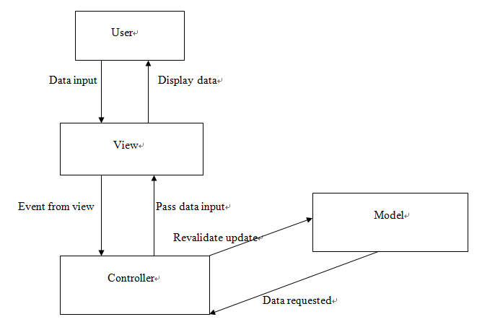

## Data Modelling

### Identifying entity type

|  |  |  |  |
| --- | --- | --- | --- |
| Entity name | Description | Aliases | Occurrence |
| Staff | General term describing all the staffs in the casinos who takes responsible of reporting machine problem and have registered the website. | floorManager | Each staff who has registered the website then will be able to report problems. . |
| Operator | General term describing the all the operators in the LT Game company who takes the responsibility of tracking and reporting the status of the machine problem. | Operator | Each operator who has registered the website then will be able to manage the post from the staffs in casinos. |
| Case | General term describing what problem the staff has reported, with the post status, which are pending, under solving, solved. | Post | Each post shows which staff reported it and the post status. |

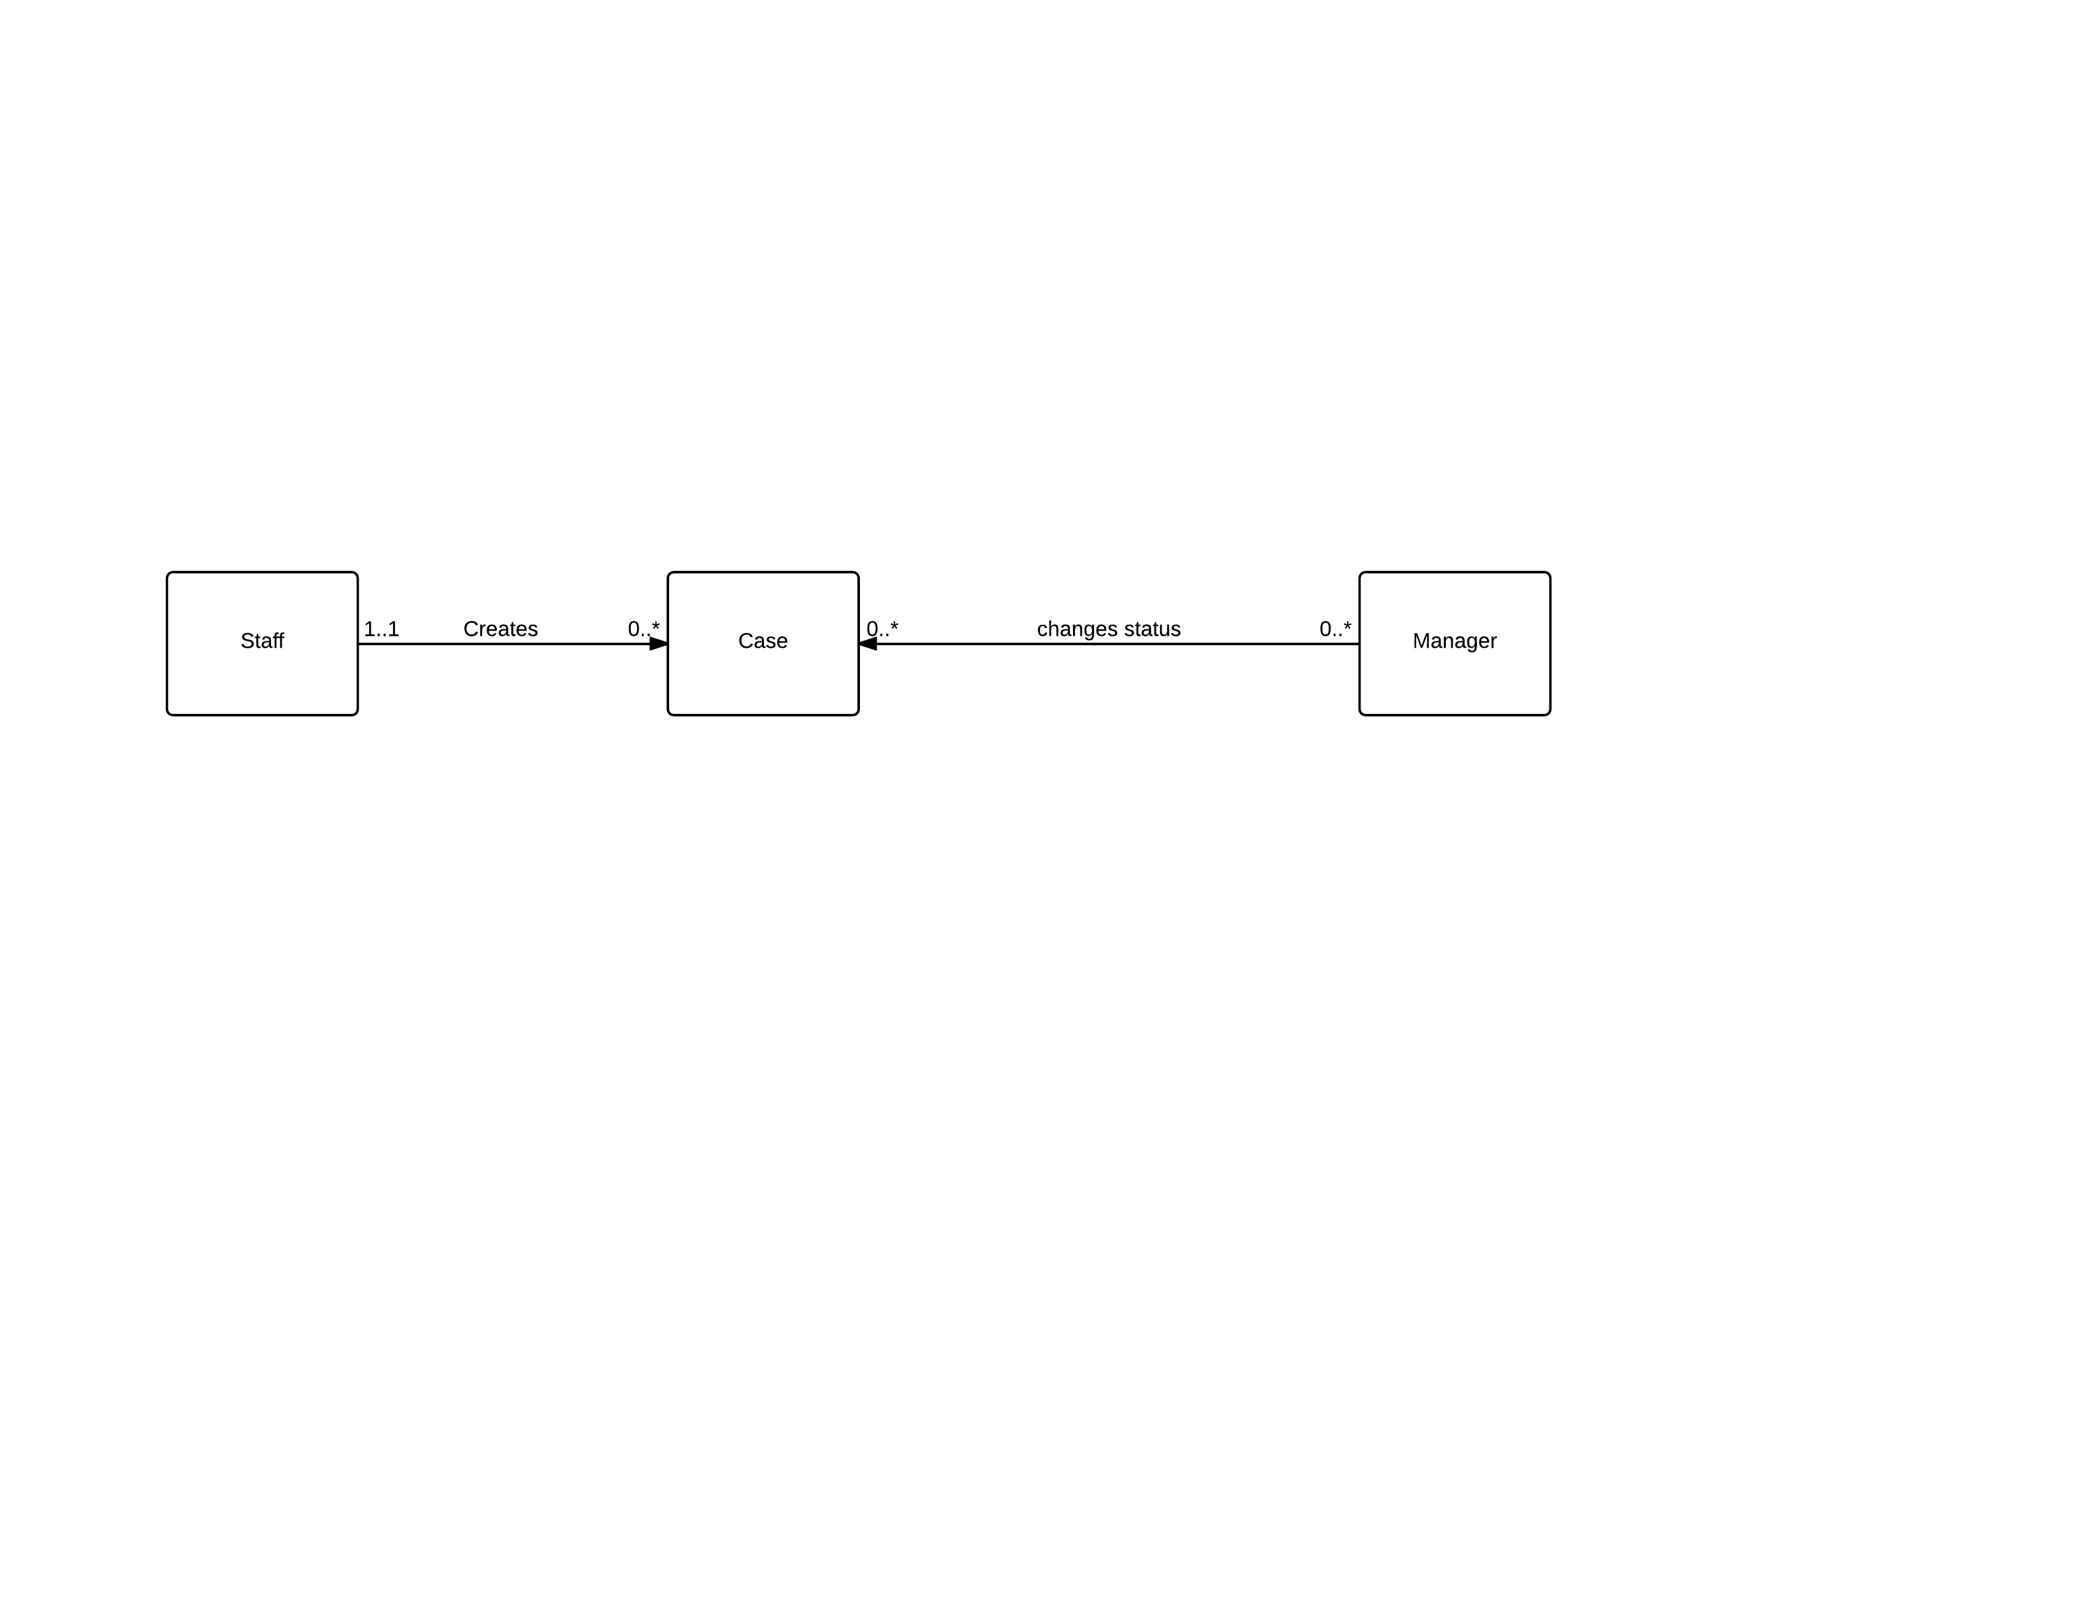

The following is the state diagram of the database schema

|  |  |  |  |  |  |
| --- | --- | --- | --- | --- | --- |
| Entity name | Attributes | Description | Data type &length | Nulls | Multi-valued |
| Staff | Email | Uniquely identity email of staff in casinos | 30 variable characters | No | No |
| Name | The name of staff | 15 variable characters | No | No |
| Company | The company of the staff | 50 variable characters | No | No |
| Password | Password for user verification | 6-16 characters and both number and character are required | No | No |
| Case | Subject | The subject of the post | 30 variable characters | No | No |
| description | The description of the post | 200 variable characters | No | No |
| PostDate | The date the staff that post the problem | Date | No | No |
| status | The problem of posts’ status | 15 variable characters | No | No |
| Operator | Email | Uniquely identity email of operator | 30 variable characters |  |  |
| Name | The name of operator | 15 variable characters |  |  |
| Password | Password for operator verification | 6-16 characters and both number and character are required | No | No |

UML diagram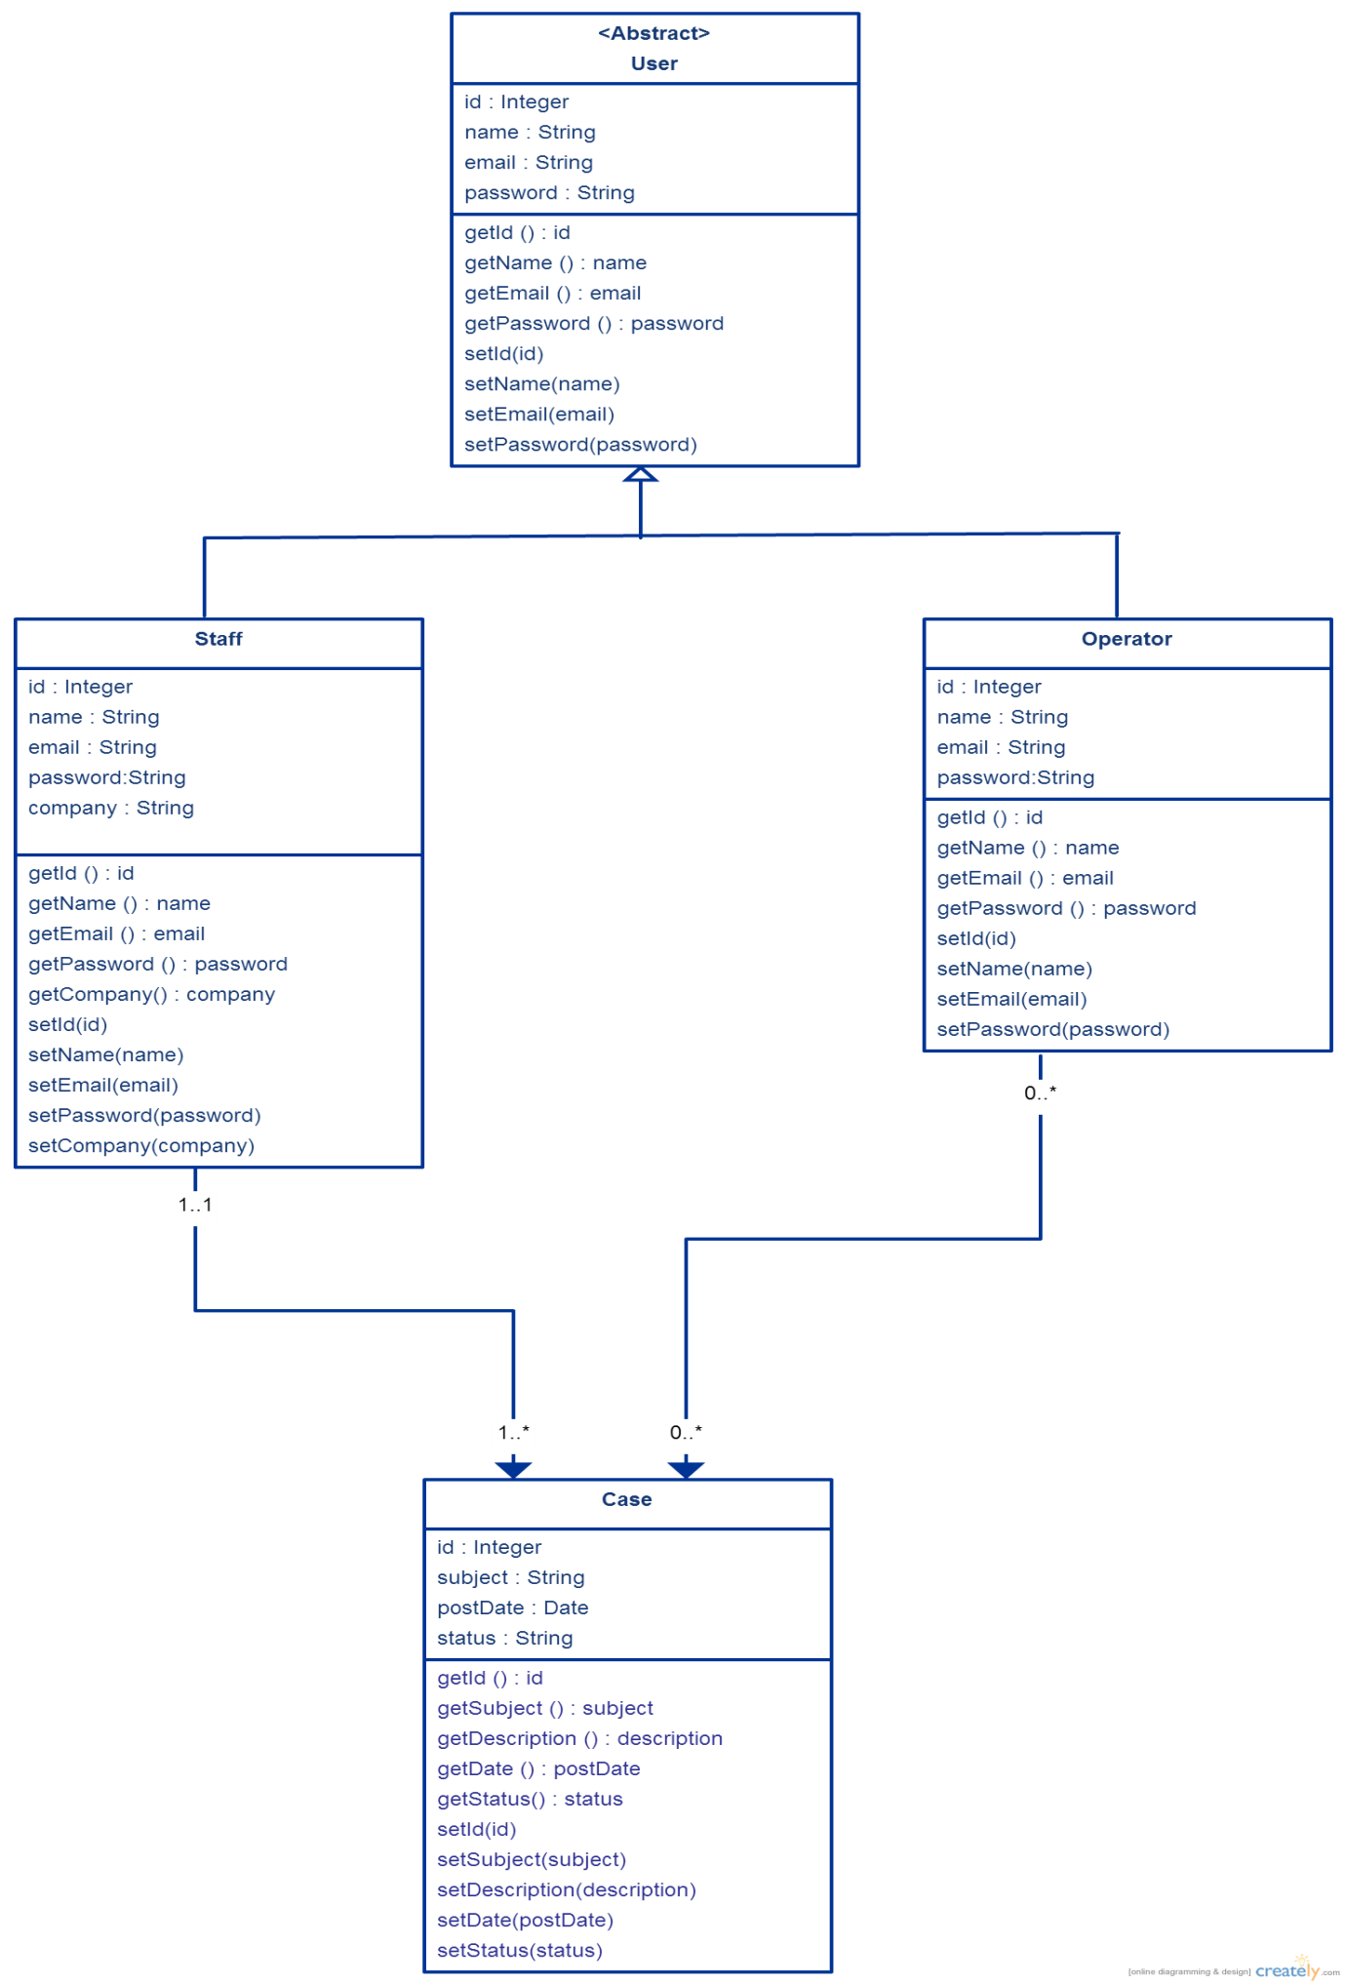

The following is the sequence diagram of staff in casinos create a new case.

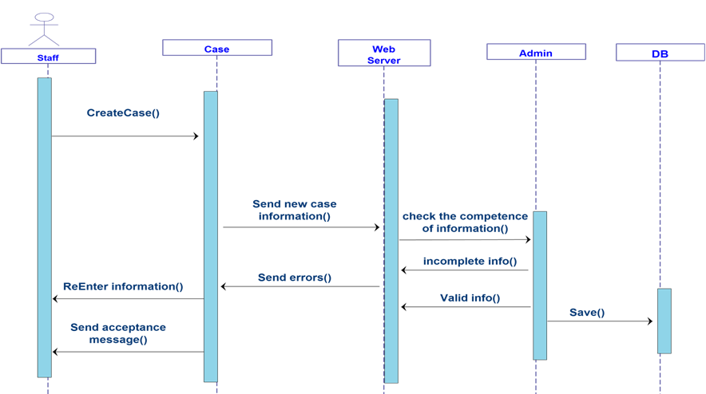

The following is user diagram which show the progress of the main function.

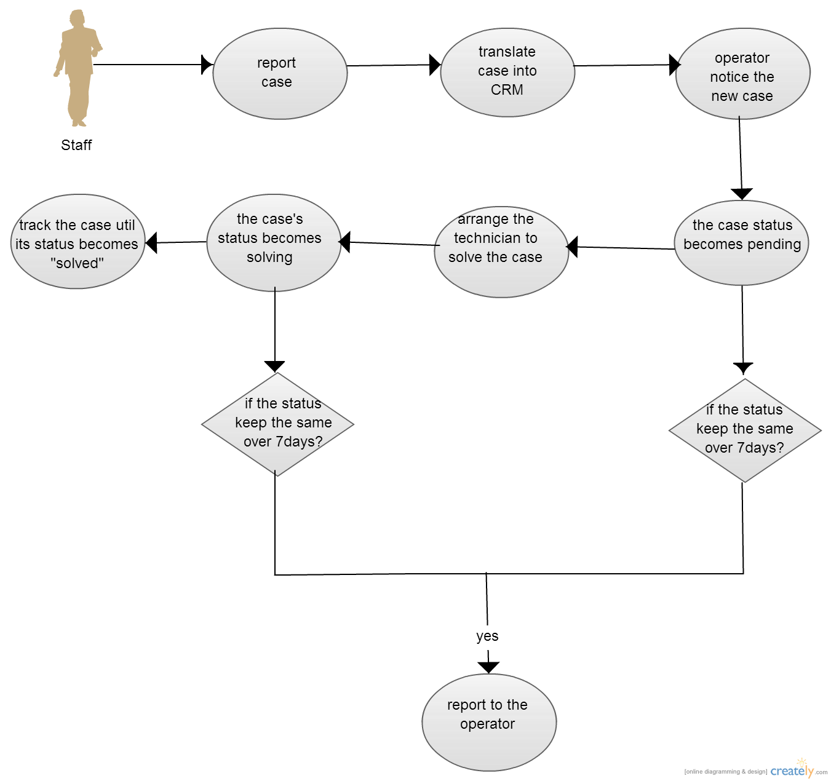

## Enhancement to existing system

The enhance CRM will be design as a new application used by both the casino and LT Game. This CRM provides an easy to learn interface for casino staff which problem reports can be type in a text box instead of using the SugarCRM or Excel file. Data input to this system will be transferred to another Excel file automatically and then transfer into the CRM server. Rapidly occurs problem information will be group together and the number of similar problem occurred will be shown in the CRM interface too. This reduce the complex process of doing a report from the staff to the CRM system because what the staff need to do is type the same simple description into this application and send it out. Once a report is sent, information will be send into the CRM system as well. In the pass, after the staff sent a problem report, data entry operator in LT Game need to input it back to the SugarCRM one by one which is really inefficient. In addition, once a problem is reported, E-mail will be also sent to IT manager. Of course, rapidly occurred problem reports will be group together and if the same issue occurs over 10 times in a day a warning message will be also sent to the manager’s mobile-phone. Moreover, the system server will check reported issues every day. If an issues is reported over 10 days but not yet closed, a warning e-mail will be sent to the managers and technicians who are related to the issues.

## Key problems and their solutions

During the implementation process, some problems occurs. For example the project met problem in installing into the LT Game’s system. To install this enhance CRM needs authorization from the COO in LT Game. Also, problem occurred in promoting this new CRM to casino manager and IT technician as they are unwilling to learn a new system. Also, a lot of managers are unwilling to spend time to have an extra training. Therefore, the importance of using a new CRM is explained to them so that they would attend the training section and learn how to use it effectively.

# Results and discussion

## Project Outcome

After implementation, this section will show the outcome of the project.

In the whole process, we firstly select one person as a representation to go to the LT Game and become a part of its staff to use the SugarCRM. After using the system in three months, a list of problems are indicated. After one week, all the members in this project sat together and have a meeting with LT Game. In the meeting, most of the requirements are discussed and in the next week all the requirements are listed in a document. In the next two weeks, plan and analysis processes are done and the project move on to the implementation. Base on the requirements, a prototype of the enhance CRM is proposed. In the enhance CRM, most of the main functions in SugarCRM used by LT Game is also presented and added functions following the requirement is also implemented. And now the new CRM system is much more powerful function and a much more user-friendly interface.

In this enhanced CRM system, functions in SugarCRM like input reports, list all the reports, etc. are presented in the system as well. And new functions according to the requirement were implemented as well. This new CRM system can exactly solve problems list in section 3.1 and fulfill the requirement of LT Game. In addition, a client application was implemented for both LT Game and casino manager.

In the client application now user can do the following actions:

**Casino floor manager:**

* Create new account for IT support member
* Import account by using system template.
* Change account information under his/her group

**Casino IT technician:**

* Login their own account
* Report new cases
* Select the priority of the case

**LT Game manager:**

* Create new account
* View all the created accounts in group of casinos.
* View all the reported cases
* Change case status
* Search case
* Sort search results by case name, status, subject, people to assign, account name, priority

**For all Client:**

* Run on windows and MAC os
* Respond time is about 1.5 seconds
* Bio-language interface with English and Chinese
* Change display language in option
* Register into the system
* Use e-mail front name as the account name

**For server:**

* Run on windows and MAC os.
* Run for 24-hour
* Do maintenance with a copy of all the data in server database
* Update maintained data in 2 minutes
* Check not yet closed case
* Send warning to LT Game manager, casino floor manager and casino IT support for not yet closed cases last for over a week

## System evaluation

With the prototype some tests are also done to evaluate system performance.

For doing user testing, the system is distribute to users use it. After a few weeks, some feedback are received from the users. Over 80% users consider this enhance CRM is useful. Most of these user also said it is easy to learn the new CRM.

### Test Case



According to the methodology mentioned before, we propose a set of test cases to check whether the new system solved problem of SugarCRM stated in Ch2. In the next paragraph, some of the most important test cases will be shown.

The first test case is “import new case”. In this testing, a floor manager account was used to try to import a new case call “test case”. With a client application, the floor manager could input a new case directly. And once he reported the new case, the data is transfer into the system server immediately. After reporting the case manager in LT Game can search the case in the server. And as requirement listed in 3.1.1.1, now in the new CRM system can search any cases not only with the first word in the title but also any words appear in the title. After solve the issue the manager in LT Game can change the status of the issue.

Another test case is “automatic warning for not yet close cases over 7 days”. In this case, in one week, every day at 2:00 a.m. the server would make a copy backup of all the reported cases and then did the checking. All the cases reported over 7 days but not yet closed were selected. After selecting out those cases, e-mail addresses of responding managers (both LT Game and casino) were checked out and then a warning message was sent. It was proved that all the manager received the warning e-mail.

# Appendix

## Project plan

Gantt Chart

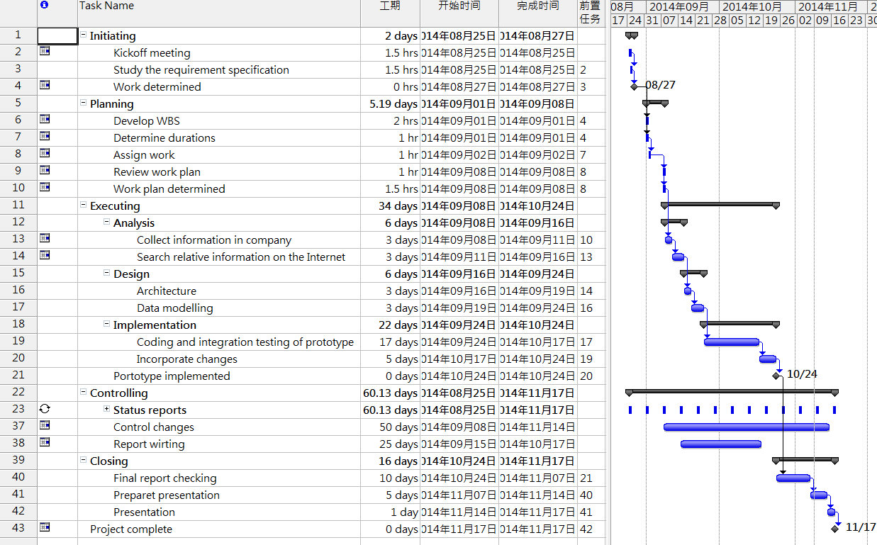

# Refernces

[1] LT Game web page. [http://www.LT Game.com/about.aspx](http://www.ltgame.com/about.aspx).[Sep. 10, 2014]

[2] SugarCRM company web page. <http://www.sugarcrm.com/>.[Sep. 10, 2014]

[3] Talkincloud. <http://talkincloud.com/sugarcrm-wins-ibms-crm-business-ibm-unveils-new-bi-tools>. [Sep. 10, 2014]

## Peer Assessment Form

|  |  |  |  |  |  |  |
| --- | --- | --- | --- | --- | --- | --- |
| S:\3rd ITC\2nd ITC\MPI_logos\MPI logo09_C349 CPE.tif  BSc. in Computing 2013/14  COMP321 Information System Implementation  Peer Assessment Form | | | | | | |
| Group number |  | | | | | |
| Group members | |  |  |  | | --- | --- | --- | |  | Student ID | Student name | | *1.* |  |  | | *2.* |  |  | | *3.* |  |  | | *4.* |  |  | | 5. |  |  | | | | | | |
| Contribution **(**Each row must total to 100%) | | | | | | |
|  | | Member 1 | Member 2 | Member 3 | Member 4 | Member 5 |
| 1. Project leadership | | % | % | % | % | % |
| 2. Data modeling | | % | % | % | % | % |
| 3. User interface design | | % | % | % | % | % |
| 4. Program development | | % | % | % | % | % |
| 5. Solving technical problems | | % | % | % | % | % |
| 6. Testing and sample data | | % | % | % | % | % |
| 7. Report writing | | % | % | % | % | % |
| 8. Preparing / giving presentation | | % | % | % | % | % |

By default, the eight items above have the same weight when calculating the overall contribution percentage. You are welcome to suggest different weight if you consider some aspects should carry more weight.